*National Institution of Technology, Rourkela*

Enhancing MNIST Data with

Channel Attention Mechanism (CAM)

Keerthi Reddy, Korla Sumana, Kasi Priyanka, Ch. Sravani, ECE dept.

***Abstract — Convolutional Neural Networks (CNNs) have achieved remarkable success in various computer vision tasks, including image classification. However, for complex datasets like MNIST, where images are grayscale and relatively simple, traditional CNN architectures may lead to overfitting or inefficient feature extraction.***

***To address these challenges, we propose a novel Channel Attention Mechanism (CAM) integrated into a standard CNN model for the MNIST dataset. The proposed CAM leverages channel-wise attention to adaptively recalibrate feature maps at each layer of the network. By focusing on informative channels and suppressing less relevant ones, the CAM enables the network to concentrate on the most discriminative features, leading to improved generalization and better performance on the MNIST dataset.***

***In this work, we propose an end-to-end deep network for convolutional layers, which is one of the critical steps in Image Detection. The key principle of the proposed CAM is to adaptively enhance the detection through attention. And the results reveal that our method significantly outperforms the other methods.***

***Index Terms — Channel attention, MNIST data set, Convolutional neural networks, Pooling, Flattening, edge detection, SoftMax function, TensorFlow***

**C**

# I. INTRODUCTION

hannel attention is a powerful mechanism that has emerged as a fundamental building block in Convolutional Neural Networks (CNNs) for various computer vision tasks. CNNs have revolutionized the field of computer vision by demonstrating exceptional performance in tasks such as image classification, object detection, segmentation, and more. However, as CNNs grow deeper and more complex, they face challenges in efficiently capturing and utilizing the most relevant information from the input data.

Channel attention mechanisms enable the network to learn which channels containing the most relevant and discriminative features. It can help mitigate overfitting by suppressing noisy or less informative channels, effectively regularizing the network. In tasks like object detection or segmentation, channel attention can highlight relevant regions in the input image by emphasizing the channels that capture essential object characteristics.

# The MNIST dataset is one of the most well-known and widely used datasets in the field of machine learning and computer vision. It stands for "Modified National Institute of Standards and Technology". The dataset consists of handwritten digits from 0 to 9, each represented as a 28x28 grayscale image. There are 60,000 training samples and 10,000 testing samples, making a total of 70,000 images.

Key Characteristics of the MNIST Dataset:

1) Grayscale Images:

Each image in the MNIST dataset is represented in grayscale, meaning that it contains only one channel (intensity values). Grayscale images simplify the complexity compared to colour images, making them a suitable starting point for learning image classification tasks.

2) Uniform Size:

All images in the MNIST dataset have a fixed size of 28x28 pixels. This uniformity facilitates the processing of the dataset, as it ensures that all samples have the same dimensions.

3) Handwritten Digits:

The dataset contains handwritten digits ranging from 0 to 9, making it a multi-class classification problem. This variety of classes challenges algorithms to distinguish and classify different digits accurately.

Convolutional Neural Networks have demonstrated superior performance in various computer vision tasks, including digit recognition. They can effectively learn hierarchical features from the images.

# II. RELATED WORK

## Researchers have explored various architectures and applications to leverage channel attention for improving the performance of deep learning models in image-related tasks. Here's an overview of some existing literature and research on channel attention mechanisms and their applications in computer vision:

## A. "Squeeze-and-Excitation Networks" (SENet):

The SENet, proposed by Jie Hu et al. in 2017, is one of the pioneering works in channel attention mechanisms. It introduced the concept of "squeeze" and "excitation" operations, which adaptively recalibrate channel-wise feature responses. The SE block explicitly models interdependencies between channels and enhances important features while suppressing less informative ones. SENet achieved state-of-the-art results in various image classification benchmarks, demonstrating the significance of channel attention.

## B. “CBAM: Convolution Block Attention Module”:

CBAM, introduced by Sanghyun Woo et al. in 2018, is a unified attention module that combines both spatial and channel attention mechanisms. The spatial attention module captures interdependencies between spatial locations, and the channel attention module recalibrates channel-wise feature maps. By incorporating both spatial and channel attention, CBAM demonstrates improved performance in image classification and object detection tasks.

## C. “ECA-Net: Efficient Channel Attention for Deep Convolutional Neural Networks”:

The ECA-Net, proposed by Qilong Wang et al. in 2020, introduced an efficient channel attention mechanism that reduces computational complexity while maintaining competitive performance. ECA-Net employs 1D-convolutional operations to model channel-wise interactions, making it more computationally efficient compared to 2D attention mechanisms. ECA-Net showed promising results in image classification tasks while being computationally more lightweight.

## D. “Attention Augmented Convolutional Networks”:

Attention Augmented Convolutional Networks (ANRs) were introduced by Irwan Bello et al. in 2019. ANRs combine the effectiveness of attention mechanisms with traditional convolutional operations to capture long-range dependencies in images. The attention mechanism helps ANRs focus on relevant regions and improve performance in various tasks, including image classification, object detection, and segmentation.

## E. “Dual Attention Network for Scene Segmentation”:

Dual Attention Network (DANet), proposed by Jiaolong Yang et al. in 2019, is designed for semantic segmentation tasks. DANet utilizes both spatial and channel attention mechanisms to capture rich contextual information and improve the accuracy of segmentation results. It has been demonstrated to be effective in a wide range of scene segmentation benchmarks.

## F. “Selective Kernel Networks” (SKNet):

Selective Kernel Networks (SKNet), introduced by Xiang Li et al. in 2019, incorporated a selective kernel module that dynamically combines different-sized kernels for each channel. This adaptive kernel selection allows the model to attend to relevant spatial information, enhancing the model's performance in image recognition tasks.

Attention mechanisms other than channel attention:

1) Spatial Attention: Spatial attention mechanisms focus on identifying relevant spatial regions in an image. They help the model attend to specific regions that are more informative for the task at hand. In contrast, channel attention mechanisms focus on recalibrating feature maps along the channel dimension, emphasizing important channels and suppressing less relevant ones. While spatial attention highlights spatial regions, channel attention enhances feature representations within each channel.

2) Self-Attention: Self-attention mechanisms, also known as intra-attention or scaled dot-product attention, have gained significant popularity, especially in natural language processing tasks. They enable the model to capture dependencies between different positions within the same input sequence. Self-attention differs from channel attention in that it operates on sequences of inputs, attending to different positions, whereas channel attention operates on feature maps and attends to different channels.

Channel attention and spatial attention differ in their focus and operations. Channel attention captures interactions between different channels within the same layer to emphasize important channels, while spatial attention captures spatial relationships within a feature map to highlight relevant regions. Channel attention operates within a single layer of a neural network, focusing on recalibrating feature maps along the channel dimension to enhance feature representation. Self-attention, on the other hand, operates on sequences of inputs, attending to different positions based on their relevance to other positions within the same sequence.

III. BACKGROUND & THEORY

Mechanisms of soft attention can be categorized into spatial attention, channel attention, mixed attention, self-attention. The importance of the attention mechanism in CV (computer vision) is growing, as it allows a neural network to focus more on what it should pay attention to. Channel attention and spatial attention are the two basic attention strategies now in use.

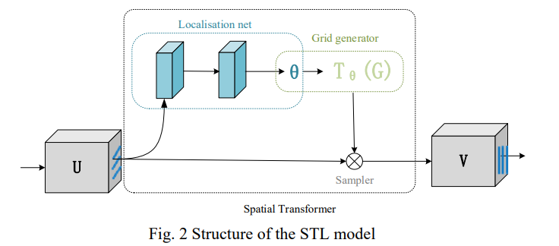Attention mechanism promotes the effect of CNN network from different aspects. CNN networks like VGGNet, GoogLeNet, and Residual-Style Networks primarily enhance the network detection capacity by widening and deepening the network, whereas the attention mechanism enhances the network performance by enhancing the expression of features and concentrating on crucial feature information and specifics. Adopting the attention mechanism will only marginally or barely increase the network’s parameters and computation while concurrently improving performance in comparison to a network with more depth and breadth.

 In computer vision, there are primarily two types of attention mechanisms that are applied: channel attention and spatial attention. The primary goal of channel attention is to locate and collect key channels and global information, whereas the goal of spatial attention is to locate and capture essential spatial and regional information.

SENet proposes the SE module (squeeze and excitation), which primary focus on the channel attention module, that can effectively deals with channel relationships. By displaying the dependency between modelling channels, it weights in the channel direction and utilizes global information to selectively highlight valid features and suppress invalid features. However, SENet’s adaptability is weak, and as the network grows, a significant number of new parameters will be introduced, slowing down the model, and it ignores the spatial information. Deep learning-based object detection algorithms are often separated into two categories: two stage detectors and one stage detectors. Two stage detectors first generate the region, which is called region proposal, and then make predictions for these proposals. A region proposal network (RPN) was suggested as a replacement for selective search, to create the regions to be detected and suggested, and then to predict and classify, which implements a full end-to-end CNN object detection model. One stage detectors take dense samples at different positions of image, and then use CNN network to extract features and directly classify and regression.

SPATIAL ATTENTION: Spatial attention differs from channel attention in that it is focused on a specific location. Channel attention is focused on ‘what’ features in the feature map are more essential, whereas spatial attention is focused on ‘where’ the key feature information is located in the feature map.

Ordinary CNN can show the translation-invariance and implicit rotation-invariance of learning. Compared with the networks learning things implicitly, an explicit processing module is preferred for the network to handle all the abovementioned transformations. Consequently, DeepMind designed Spatial Transformer Layer (STL) to realize spatial invariance, and its network structure is:

Fig. 1. Structure of the STL model

The localization net firstly obtains a Θ according to the input image, U, by computation. And the grid generator then computes the coordinates of input image according to Θ and the coordinates of output image. In the end, the sampler fills image V based on the defined rules of filling (bilinear interpolation is generally used).

CHANNEL ATTENTION: The attention mechanism is derived on the human visual attention mechanism, which imitates people’s focus on different objects, and the channel attention is intended to focus on ‘what’ is most significant when given an input image.

For aggregating information, CBAM empirically confirmed that adopting both max-pooled and average-pooled features enhances network representation power far more than utilizing each alone. In a CNN, each image is initially represented by three channels (R, G, B). After being processed by different convolution kernels, each channel will generate new channels containing different information. If weights are added to each channel to show the relevance between channel and key information, a greater weight means a higher relevancy, and more

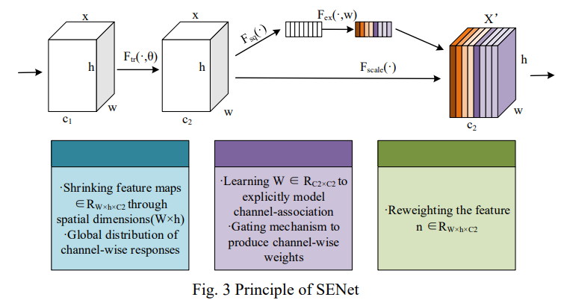attention should be paid to the corresponding channel. SENet is essentially a channel-based attention model. It models the importance of each feature channel and then enhances or suppresses it in different tasks. The principle is displayed in:

Fig. 1. Principle of SENet

A by-pass branch emerging after normal convolution is operated by squeezing, which compresses the features of spatial dimension, that is, each two-dimensional feature map becomes a real number. The next step is the operation of excitation, which generates a weight w for each feature channel to explicitly model the relevance. Once the weight of each feature channels is obtained, the weights are applied to each original feature channel, and the importance of different channels can be learned according to specific tasks.

***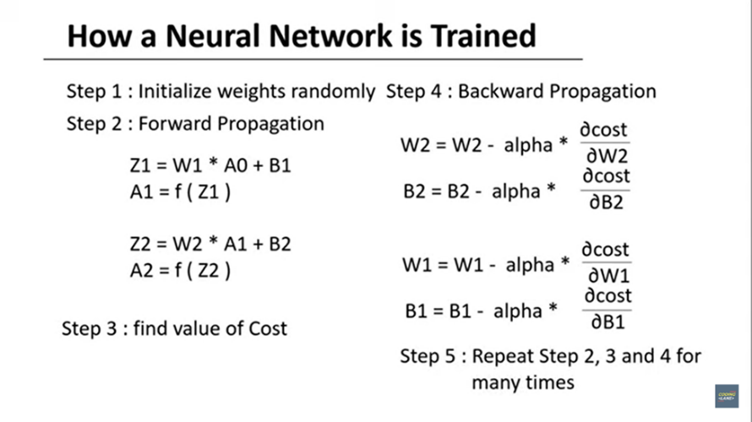****A. Problem Formulation*

## Since we initialise weights randomly, Cost function will be more.

Cost function is the error representation. To reduce cost function, we train the model with data in backpropagation and calculate the new weights. We repeat the steps till the model is accurate.

Forward propagation involves passing input data through the network and calculating the output using the current weights.

Backward propagation, also known as backpropagation, is used to calculate the gradients of the loss function with respect to the network's weights, allowing for weight updates.

## B. ReLU Function

rectified linear unit function now it is a linear function where we rectify the input which is less than 0.For every x less than or equal to 0 it gives 0 as the output and for every x greater than 0 it gives same x as the output. This function is not entirely linear as it gives zero as the output for all x less than zero while it gives linear output for all x greater than zero so it can be also said as a piecewise linear function and this actually makes it even better as it can take the advantage of both linear and non-linear property the linearity of the function can help to work on the vanishing gradient problem and also makes the training faster and because of the non-linearity we can take the advantage or the benefits of using multiple hidden layers in our neural network.

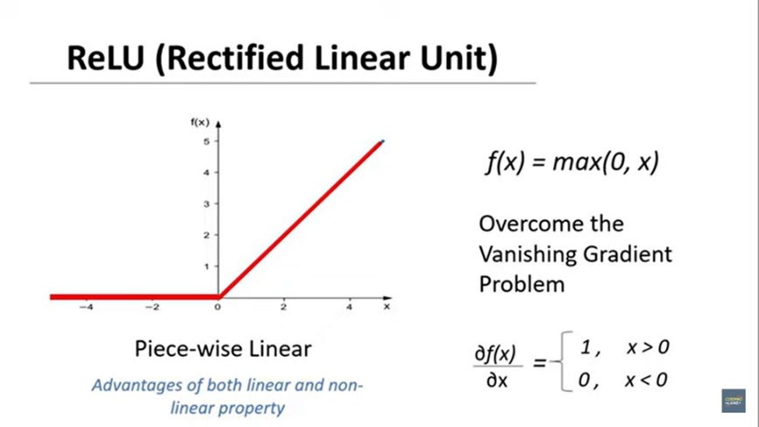

## C. Pooling

CNN uses pooling layer to reduce the size of inputs, speed up communication. Spatial Pooling is also called sub sampling or down sampling. It is applied after convolution and RELU operation. It reduces the dimensionality of each features map but retains the most important information. Since the number of hidden layers required to learn the complex relations present in the image would be large. We apply pooling operation to reduce the input feature representation there by reducing the computational power required for the network.

Types of Pooling:

Global Pooling:

It reduces each channel in the feature map to a single value. Thus, (nh) X (nw) X (nc) feature map is reduced to 1 X 1 X (nc) feature map. This is equivalent to using a filter of dimensions (nh) X (nw) i.e the dimensions of the feature map. Further, it can be either global max pooling/global average pooling. Pooling layer is used to reduce the 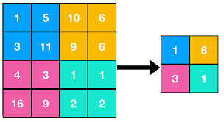spatial dimensions (i.e the width and height) of the feature maps, while presenting the depth (no. Of channels).

Max Pooling:

Once we obtain the feature map of the input, we will apply a filter of determined shape across the feature map to get the maximum value from that portion of the feature map. It is also known as sub sampling because from the entire portion of the feature map covered by filter / kernel we are sampling one sample to maximum value. It extracts the maximum information from each sample.

## 

## 

It selects the brighter pixels from the image. It is useful when the background of the image is dark and we are interested in only the lighter pixels of the image. For example, in MNIST dataset the digits represented in white colour and back ground is black, so max pooling is used. When classifying the MNIST digits dataset using CNN, max pooling is used because the background in these images is made black to reduce the computation cost.

Min Pooling:

Min pooling selects the less brighter / dark pixels from the image.  It is useful when the background of the image is white and we are interested in only the brighter pixels of the image.

Average Pooling:

Average Pooling computes the average of the elements present in the region of feature map covered by the filter. Thus, while max pooling gives the most prominent feature in a particular patch of the feature map, average pooling gives the average of features present in a patch.

Sum Pooling:

Itcomputes the sum of all the elements in that window.

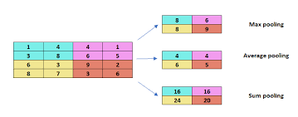

## D. Cost functions in Neural Networks:

There are 3 types of cost functions for different models in neural networks namely: regression/ linear classification, binary classification, multi-class classification.

The mostly used binary class classification has ‘Binary Cross Entropy’ Cost Function. Whereas, Multi-class classification has ‘Categorical Cross Entropy’ Cost.

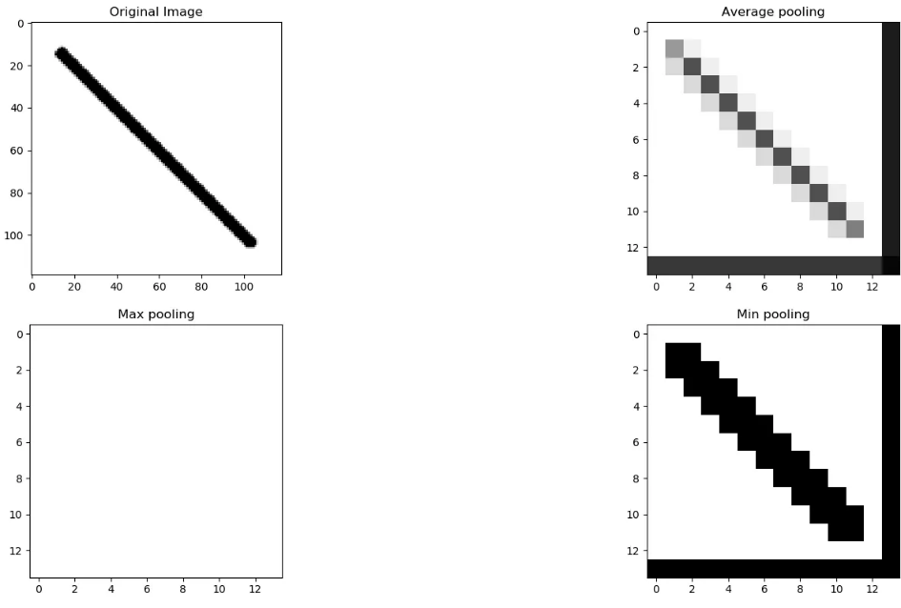

Min pooling gives better result for images with white background and black object.

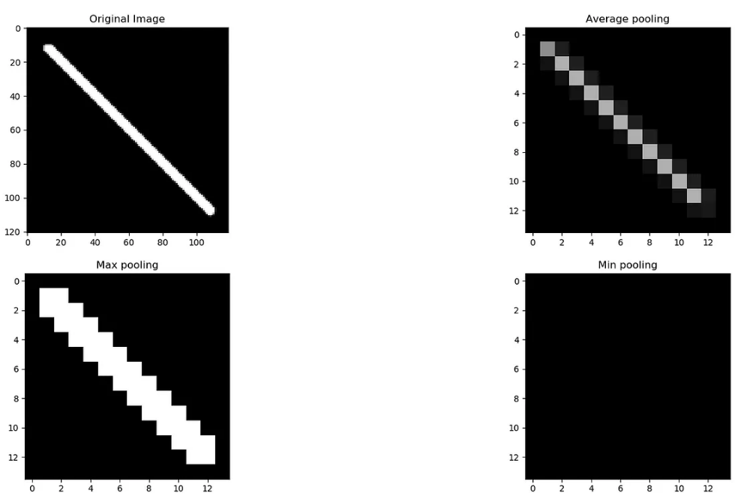 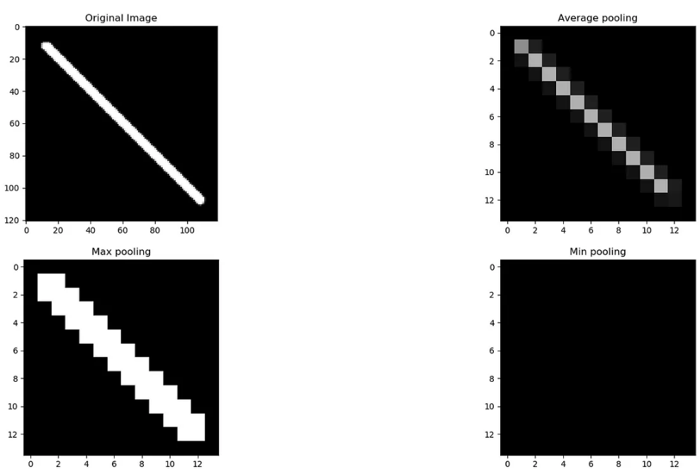

# Max pooling gives better result for the images with black background and white object (Ex: MNIST dataset) affect the classification.

*Advantages of Pooling:*

1. Dimensionality Reduction:

Reduces the computational cost and also helps in avoiding overfitting by reducing the no. of parameters.

2. Translational invariance:

Position of an object in the image does not affect the classification result, as the same features are detected regardless of the position of the object.

3. Feature Selection:

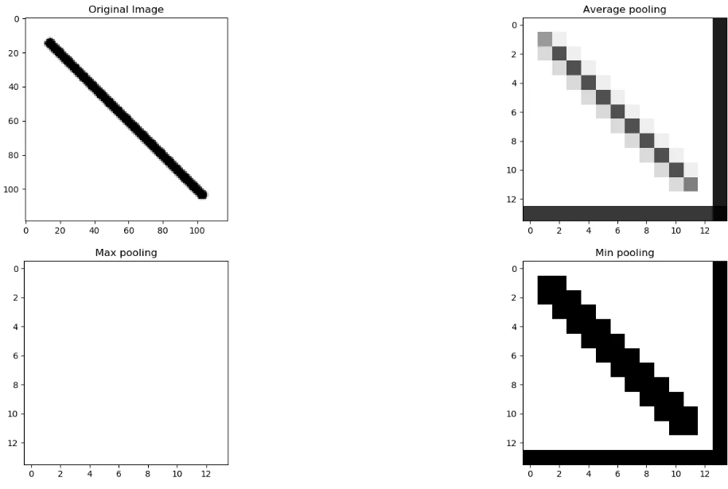Selecting the most important features from the input.

*Disadvantages of Pooling:*

1. Information Loss: They discarded some information from the input feature maps, which can be important for the final classification or regression task.

2. Oversampling: Leads to loss of some fine-grained details that are important.

3. Hyper Parameter Tuning.

So the whole process of image classification using CNN containing multiple convolution layers can be shown as:

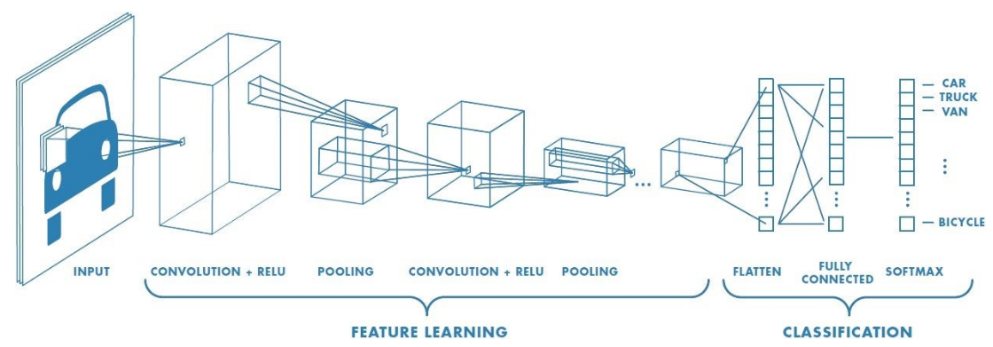

# IV. METHODOLOGY

1. Dataset Preparation:

MNIST Dataset Overview: The MNIST dataset, which consists of a collection of 28x28 grayscale images of handwritten digits from 0 to 9, has popularity as a benchmark dataset for image classification tasks.

Data Split: Divide the dataset into training, validation, and testing sets. Commonly, an 80-10-10 split is used for training, validation, and testing, respectively.

Data Loading: Load the MNIST dataset into your chosen deep learning framework, such as TensorFlow or PyTorch. In CNN, back propagation becomes very complicated, as the weight parameters computed in deep layered algorithms are present in internal structure of different convolutional layers. So, to make these implementations quick and easy, we use Tensorflow framework in python.

Data Preprocessing: Detect any preprocessing steps applied to the data, such as normalization (scaling pixel values to a range of [0, 1]) or mean subtraction.

2. Data Augmentation Techniques:

Data augmentation is a crucial step to artificially increase the diversity of the training dataset, which can improve the generalization of the model.

Random Rotation: See for any use of randomly rotated the images within a certain degree range (e.g., ±15 degrees) to make the model invariant to rotation.

Random Translation: One can also apply random translations (both horizontal and vertical) to shift the image within a certain range to enhance the model's robustness to position changes.

Random Scaling and Shearing: By randomly scaling and shearing the images we can introduce variability in size and shape, respectively.

Horizontal Flipping: Horizontal flipping can also be performed to create mirror images, especially useful for digits that are not symmetrical.

Random Noise: Random noise (e.g., Gaussian noise) can be added to the images to make the model more tolerant to noise in real-world scenarios.

Colour Jittering: If we opt to experiment with colour images (converting MNIST to RGB), random colour jittering is applied to introduce colour variations.

It's essential to strike a balance with data augmentation. While increasing diversity is beneficial, excessively aggressive augmentation might lead to overfitting or unrealistic images. Experiment with different augmentation techniques and parameters to find the optimal augmentation strategy for your model.

By carefully preparing the dataset and applying appropriate data augmentation techniques, you can improve the model's performance and enable it to generalize better to unseen data, thus enhancing the effectiveness of the channel attention mechanism for the MNIST dataset.

Here, the below images depicts a sequence of handwritten number detection overview pictorially:

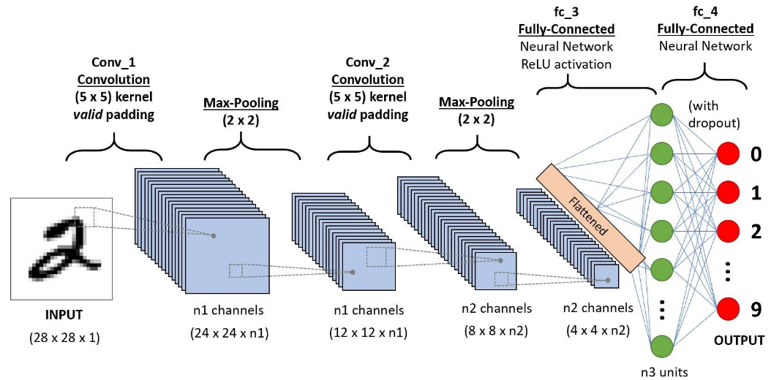

# IV. EXPERIMENTAL SETUP

1. *DATASET:*

MNIST (Modified National Institute of Standards and Technology) dataset consists of 28x28 grayscale images of handwritten digits (0-9). It contains a training set of 60,000 images and a test set of 10,000 images.

1. *DATA PREPROCESSING:*

Normalize the pixel values: Scale the pixel values from the range [0, 255] to [0, 1] to make the data more amenable for neural network training.

Reshape the images: CNNs expect 3-dimensional input (width, height, channels). Since MNIST images are grayscale, we will reshape them to (28, 28, 1).

1. *MODEL ARCHITECTURE:*

CNNs are effective for image classification tasks. A common architecture for MNIST classification is as follows:

1. Input layer: Convolutional layer with filters, activation function (e.g., ReLU), and input shape (28x28x1).
2. Convolutional layers: Stacked convolutional layers with increasing numbers of filters, using ReLU activation, followed by MaxPooling to down sample the feature maps.
3. Flatten layer: Flatten the output from the convolutional layers to feed it into the dense layers.
4. Dense layers: One or more fully connected layers with ReLU activation.
5. Output layer: Dense layer with 10 units (one for each digit) & SoftMax activation to get class probabilities.
6. *COMPILE THE MODEL:*

Select an appropriate optimizer (e.g., Adam, RMSprop), loss function (e.g., categorical cross-entropy for multi-class classification), & evaluation metric (e.g., accuracy).

1. *MODEL TRAINING:*

Train the model using the training dataset. Define the number of epochs (passes through the entire dataset) and batch size (number of samples processed before updating the model).

1. *MODEL EVALUATION:*

After training, evaluate the model's performance on the test dataset using the chosen evaluation metric. Here in this we have used accuracy to test and compare.

1. *HYPERPARAMETER TUNING:*

Experiment with different hyperparameter values, such as learning rate, number of filters, dropout rate, etc., to optimize the model's performance.

1. *REGULARIZATION:*

Implement techniques like dropout or L2 regularization to prevent overfitting.

1. *VISUALIZATION:*

Visualize the filters in the convolutional layers to understand what features the model is learning.

1. *TESTING:*

Once a well-performing model is formed, use it to predict handwritten digits from new images.

**CODE IMPLEMENTATION**

1) *Digit detection only with CNN*

Link to the code:

[DigitdetectionwithoutCAM.ipynb](https://colab.research.google.com/drive/11pKVLqz1sj-M2iN2I62AU7OL-Ha1kJlj?authuser=0)

2)*Digit detection with Channel attention mechanism after only one Convolutional Layer*

Link to the code: [DigitdetectionwithCAMinoneCNN.ipynb](https://colab.research.google.com/drive/194kTgBZQ_b_FUzizLfL7xmvrKe9nKgZS?authuser=0)

3)*Digit detection with CAM in two convolutional layers*

Link to the code: [DigitdetectionwithCAMintwoCNNs.ipynb](https://colab.research.google.com/drive/1XBToQp-_wDO5gdKtGukdxHwhcBN9CuxG?authuser=0#scrollTo=eq29Aok4XapZ)

# V. RESULTS

When applying CNNs for digit detection on the MNIST dataset, we achieved high accuracy levels because of the ability of CNNs to learn local features through convolution and pooling layers. Our CNN model now tends to generalize well to new, unseen data, which means it can accurately detect digits from handwritten images that are not part of the training set.

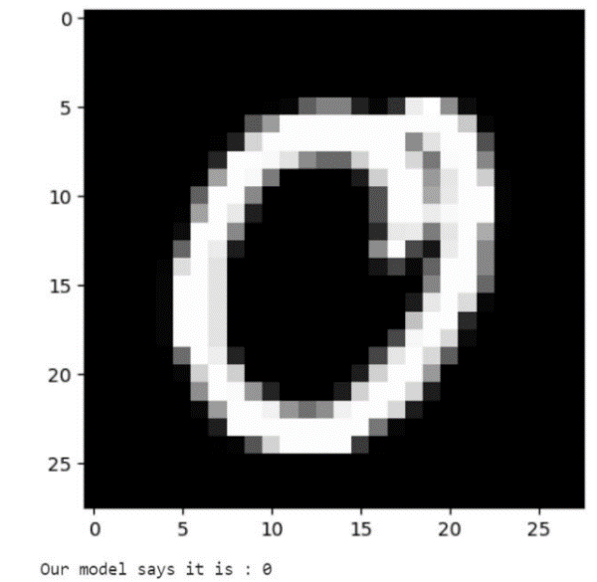

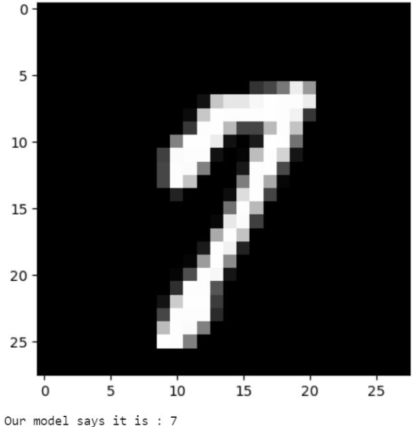

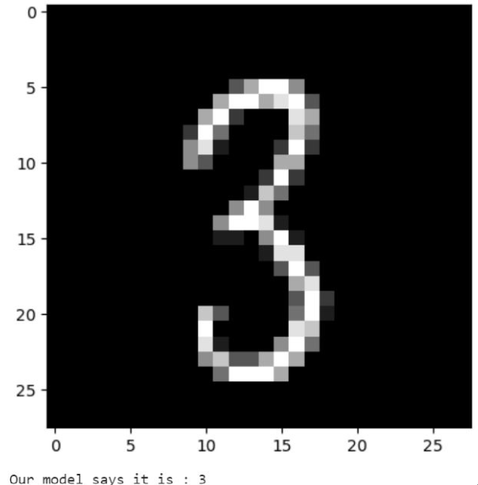

And when we used Channel Attention Mechanism with Convolutional Neural Networks (CNNs) our model gave remarkable results, significantly enhancing the accuracy and generalization capabilities of the model. The attention mechanism enabled the network to emphasize essential channels in the feature maps, leading to a better

representation learning and classification performance.

Channel attention mechanism provided interpretability, as we analysed which channels are most relevant for digit detection. This insight helped in understanding the model's decision-making process and identifying which features are crucial for accurate classification.

1) *Digit detection only with CNN:*

Results:

Test Loss: 0.026553576812148094

Test Accuracy: 0.9902999997138977

2)*Digit detection with Channel attention mechanism after only one Convolutional Layer*

Results:

Test Loss: 0.02544071152806282

Test Accuracy: 0.9915000200271606

3)*Digit detection with CAM in two convolutional layers*

*Results:*

Test Loss: 0.02444071152806282

Test Accuracy: 0.9945000200271606

# V. CONCLUSION

The MNIST dataset is a popular benchmark dataset for digit recognition, containing 28x28 grayscale images of handwritten digits from 0 to 9. Convolutional Neural Networks (CNNs) are widely used for digit detection in the MNIST dataset due to their ability to capture spatial features and patterns.

Convolutional Neural Networks have demonstrated superior performance in various computer vision tasks, including digit recognition. They can effectively learn hierarchical features from the images, making them highly suitable for detecting patterns and structures in handwritten digits. To further enhance performance and avoid overfitting, data augmentation techniques (such as rotation, scaling, and flipping) are often used to artificially increase the size of the training dataset.

The architecture of a ConvNet/ CNN is analogous to that of the connectivity pattern of Neurons in the Human Brain and was inspired by the organization of the Visual Cortex. Individual neurons respond to stimuli only in a restricted region of the visual field known as the Receptive Field. A collection of such fields overlap to cover the entire visual area. The abstract representation that we get from CNN i.e, Convolutional Neural Network contains all the information that is there in the Image. Therefor, CNN’s are used to encode the image.

RNN is used to decode from the encoding. RNN i.e, Recurrent Neural Network is used for Sequential data.

If we have to work with both Sequential data and Images like in image questioning, we concatenate them. To deal with Sequence of images like in videos we use RNN of CNN’s that means we encode every image using CNN and pass it through RNN.

The success of the Channel Attention Mechanism on the MNIST dataset implies its potential for real-world applications in digit recognition and other image-based tasks. Its ability to improve accuracy and generalization makes it valuable for numerous practical scenarios. The CAM is an attention mechanism specifically designed to capture channel-wise relationships within feature maps, allowing the model to focus on the most informative channels while filtering out irrelevant or noisy information. The attention mechanism enables the network to emphasize essential channels in the feature maps, leading to better representation learning and classification performance.

The CAM can accelerate the training process by providing more meaningful gradients during backpropagation. This faster convergence allows for quicker model development and experimentation.

As the field of deep learning continues to advance, there are several potential applications and future research directions for channel attention mechanisms:

1) Image Classification: Channel attention can significantly improve image classification tasks by enabling the network to focus on discriminative features, leading to enhanced accuracy and better generalization.

2) Object Detection: In object detection tasks, channel attention can aid the network in localizing and recognizing objects by highlighting relevant features, thereby improving detection performance.

3) Semantic Segmentation: Channel attention mechanisms can be applied to semantic segmentation tasks to help the model better understand object boundaries and produce more accurate segmentation masks.

4) Image Super-Resolution: In the context of image super-resolution, channel attention can help the network to attend to important image details while discarding noise, leading to higher-quality upscaled images.

5) Image Captioning: Channel attention can play a crucial role in image captioning by assisting the model in focusing on salient regions in an image while generating captions.

6) Visual Question Answering (VQA): For VQA tasks, channel attention can help the model to selectively attend to relevant regions of an image when answering questions.

7) Video Analysis: Channel attention mechanisms can be extended to video processing tasks, such as action recognition, to capture temporal dependencies and improve performance.